**Inventory Management Application using Microsoft Azure:**

Create Resource

Create Web Application

After deployment resource group overview

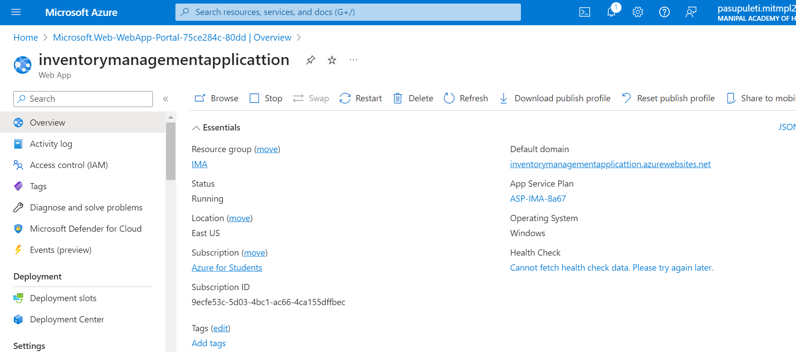

Create a new project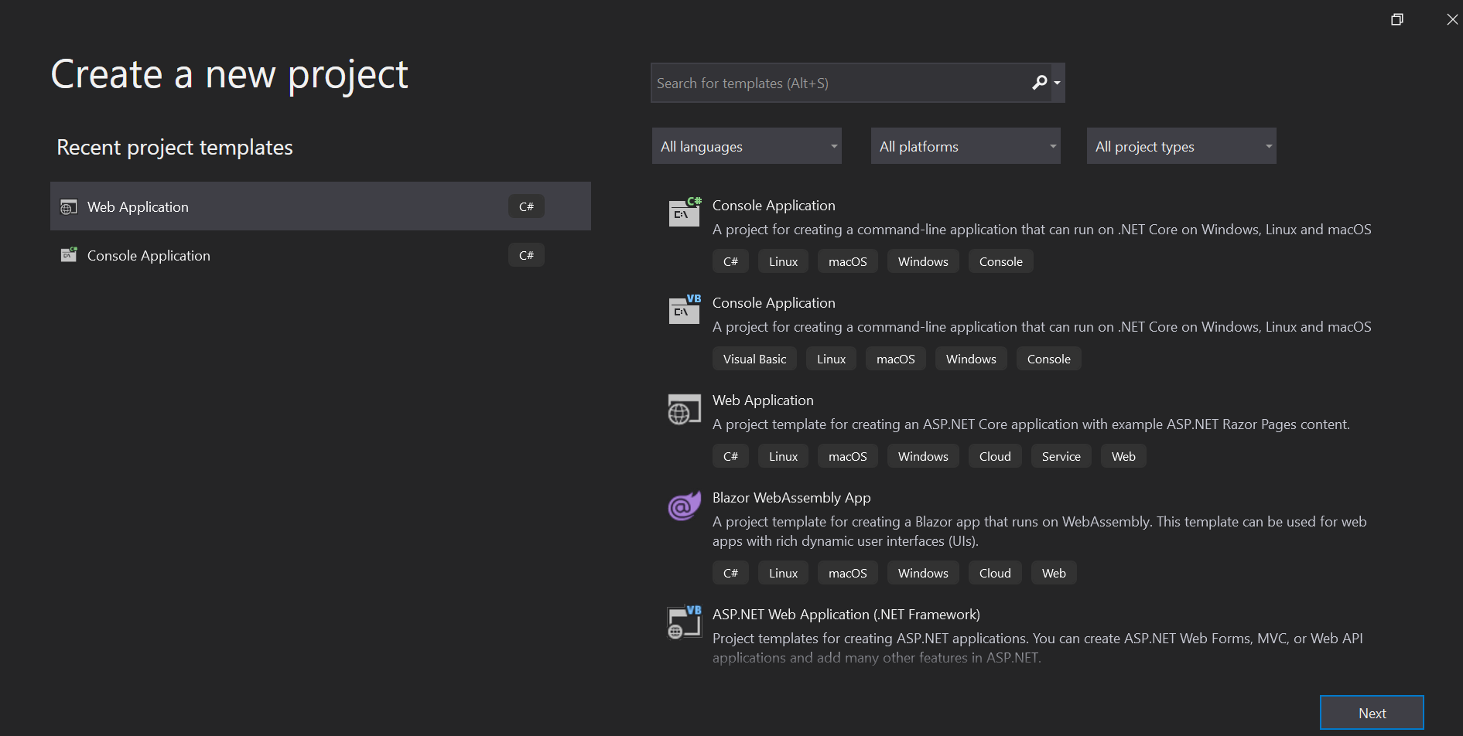

Configure your new project as Inventory management app

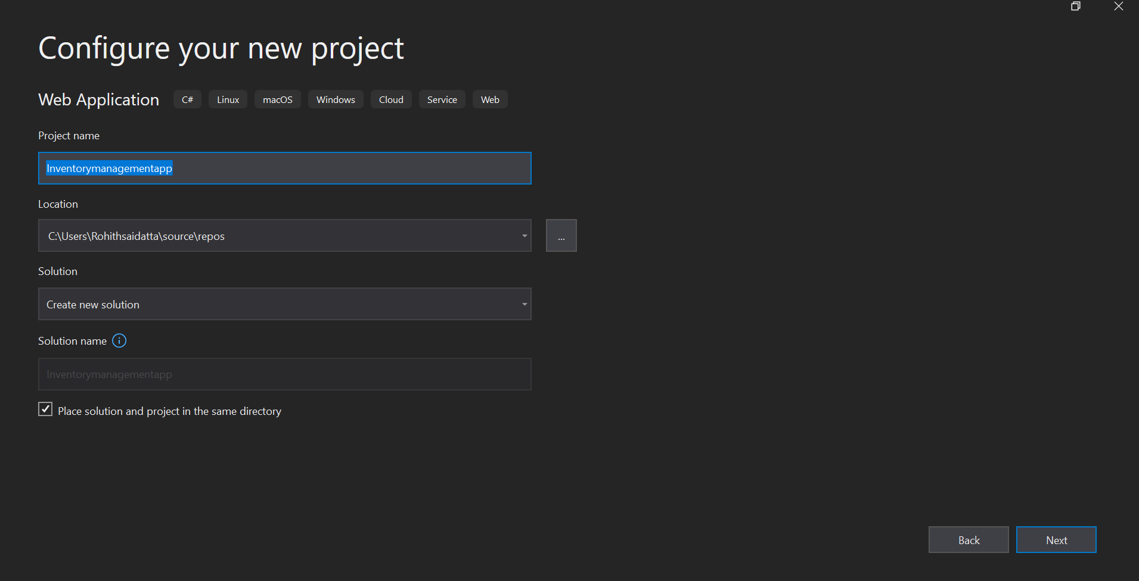

Additional information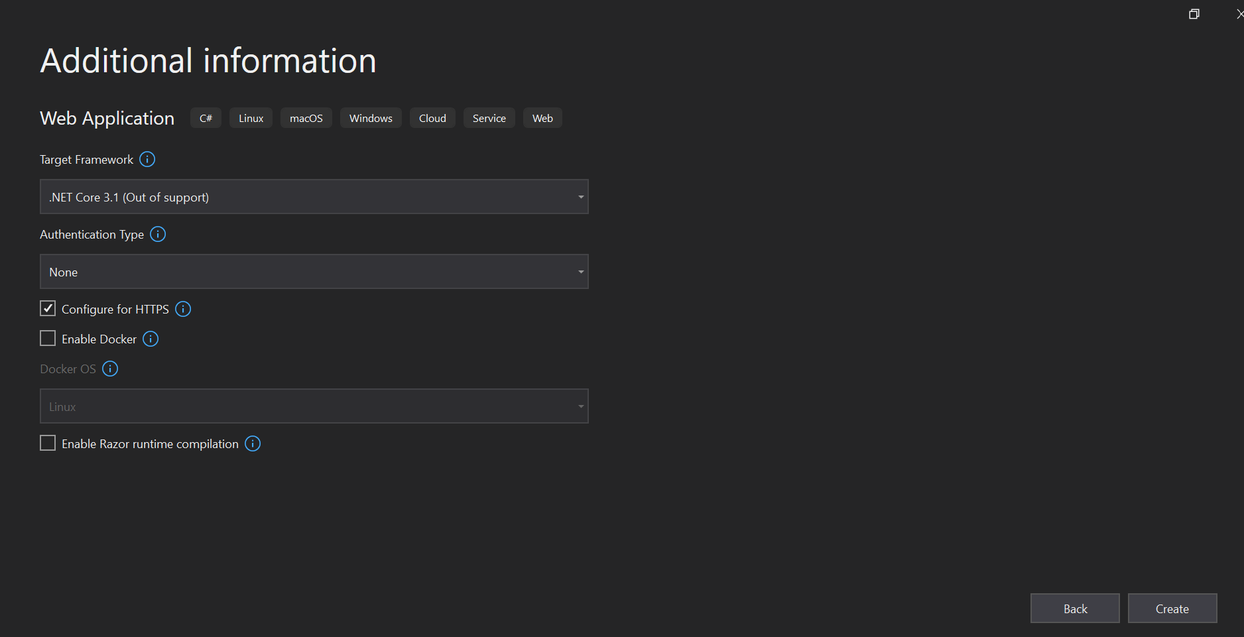

Inventory Management app User Interface while running locally

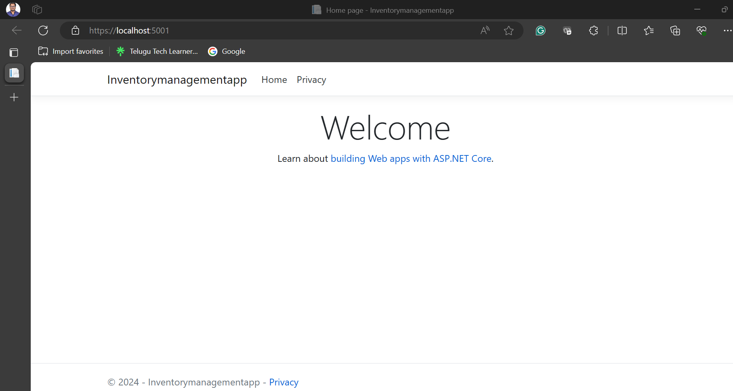

Publishing it into Azure

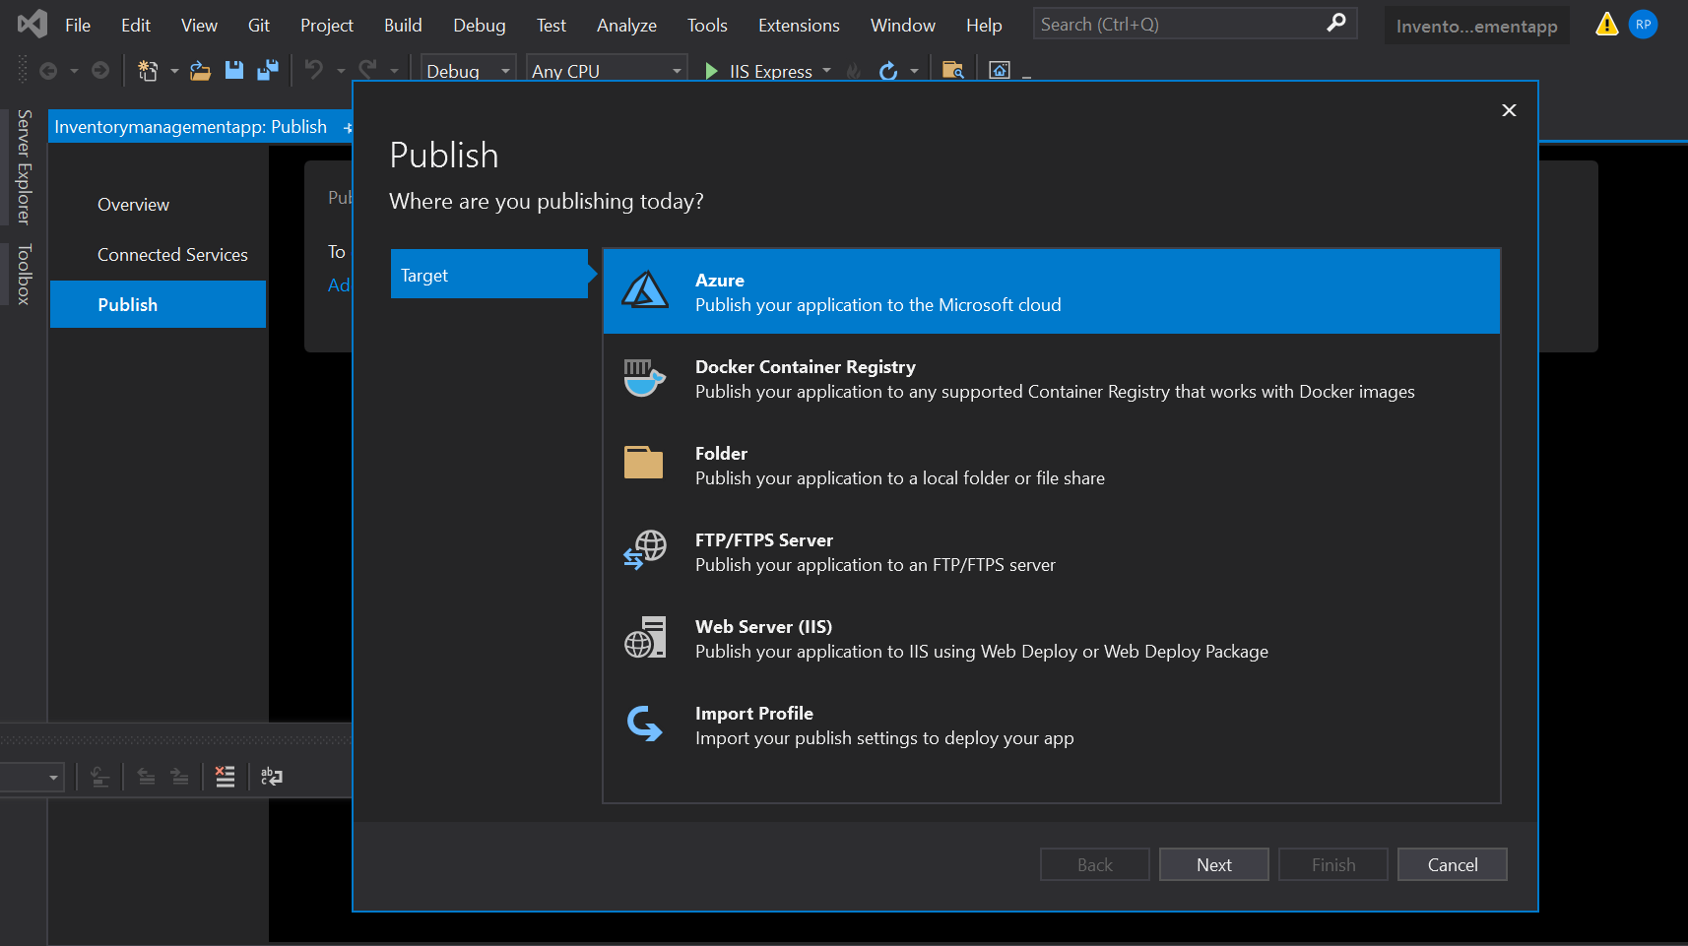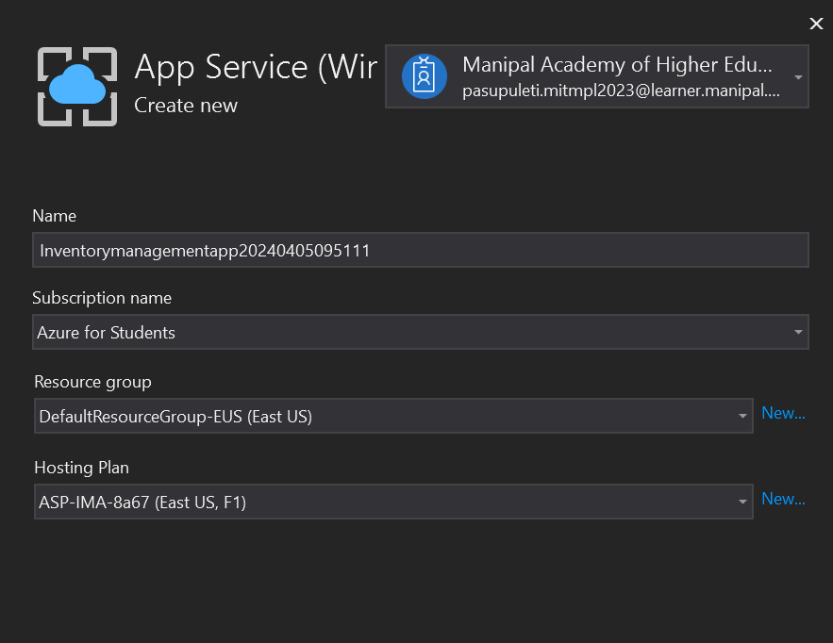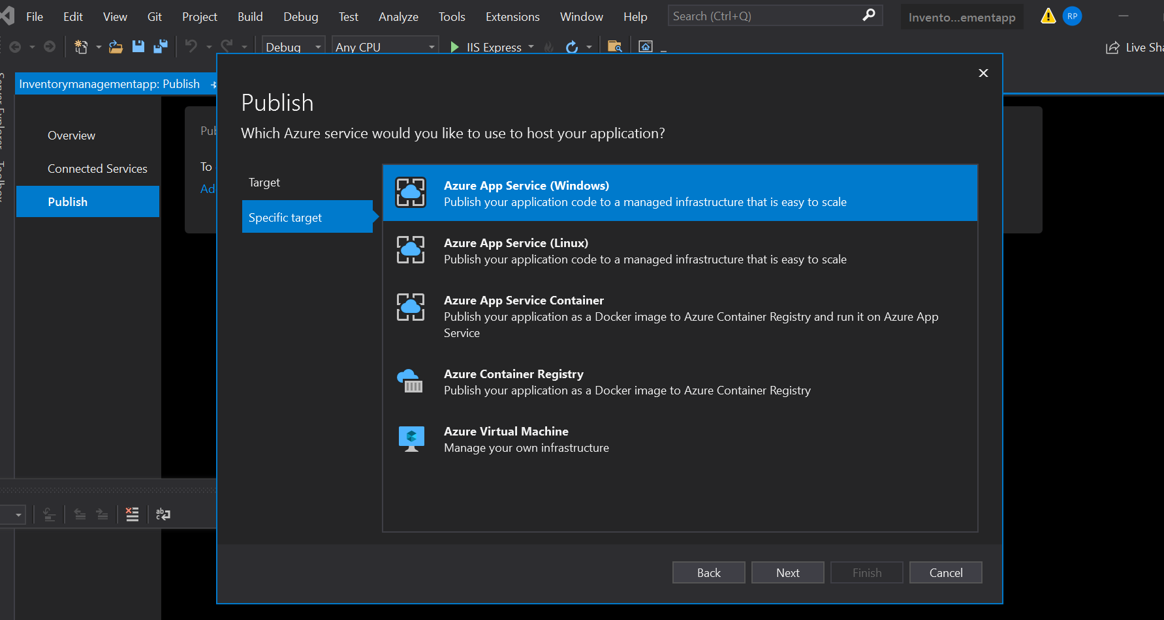

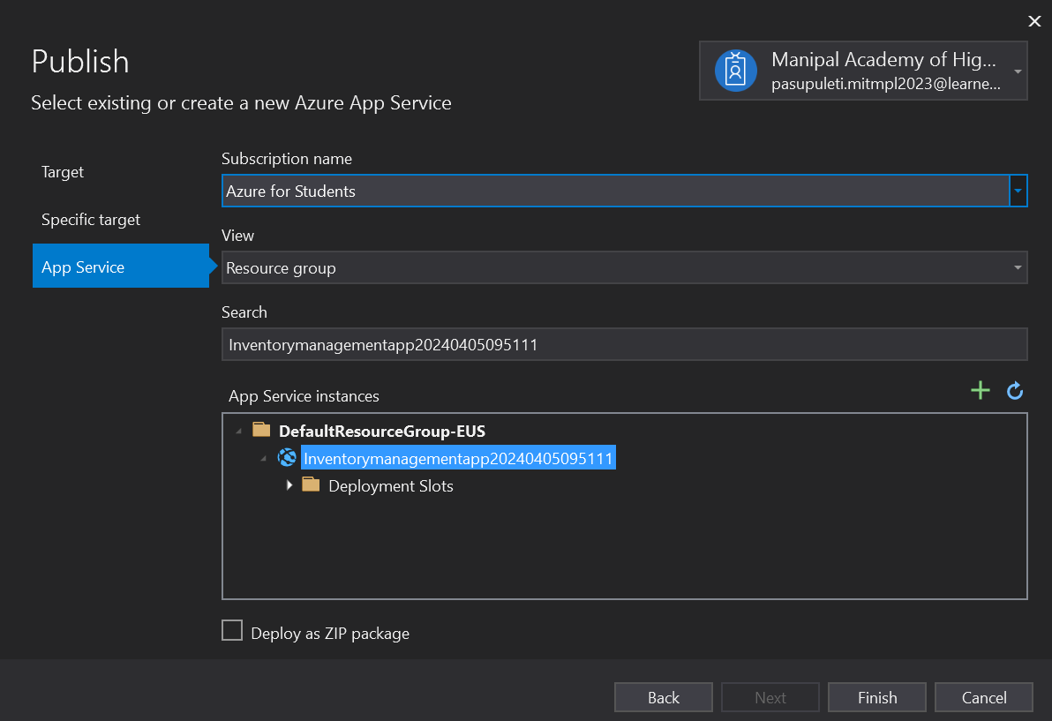

Solution explorer of Inventory Management App

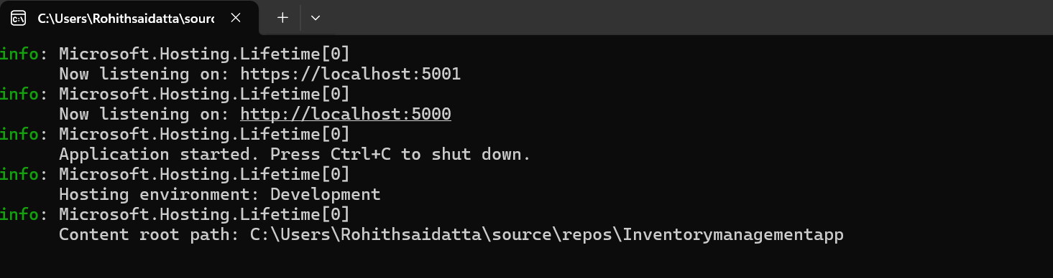

After publishing it into Microsoft azure

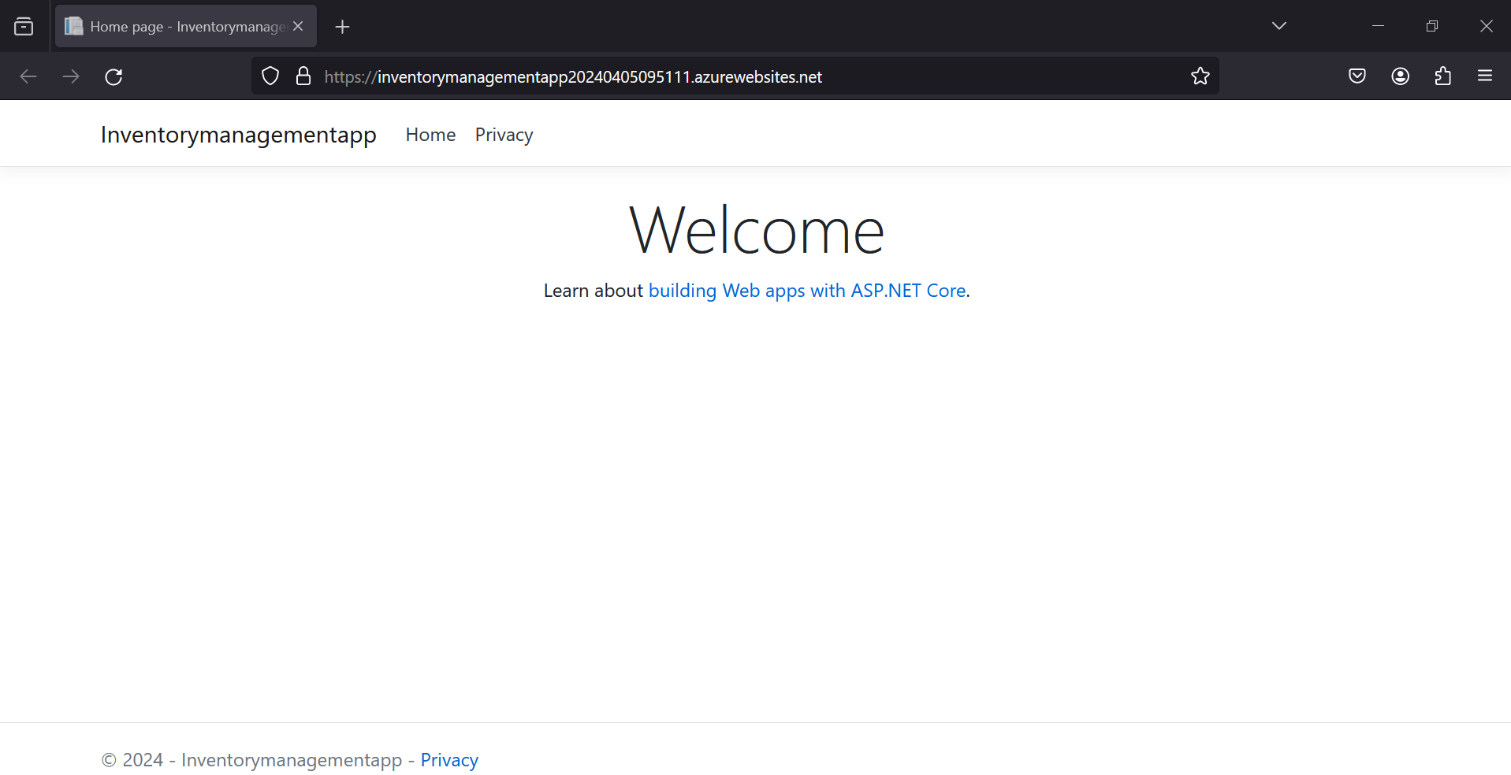

Configure Azure SQL Database

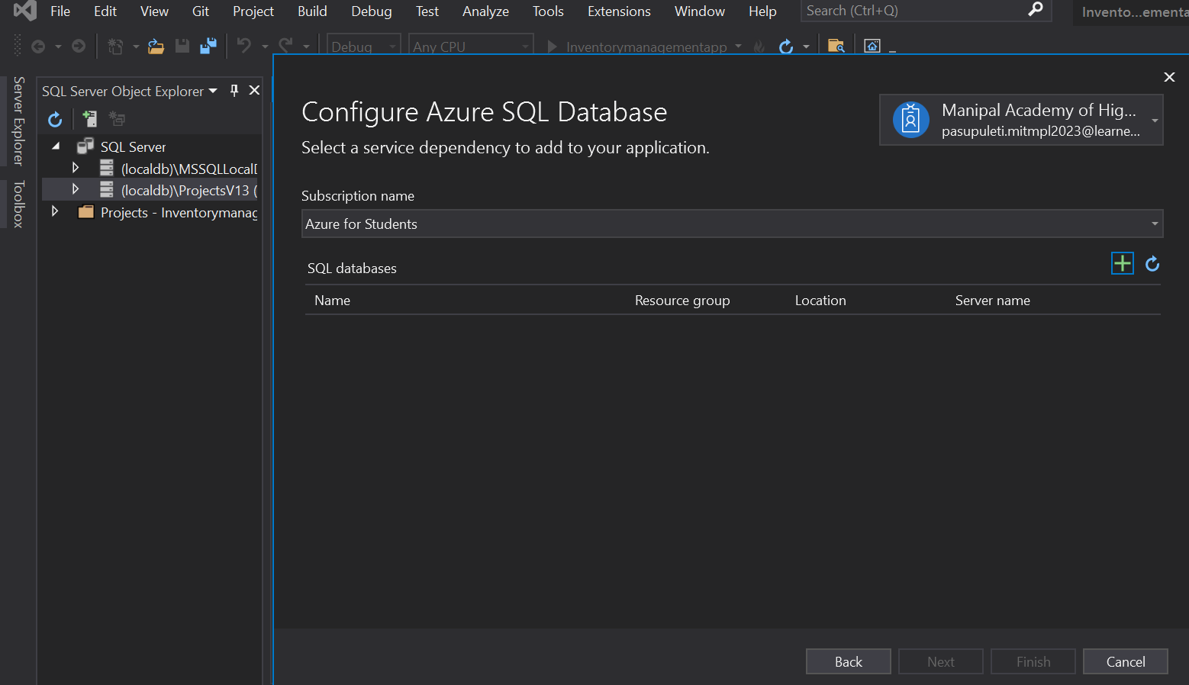

Create new SQL Server

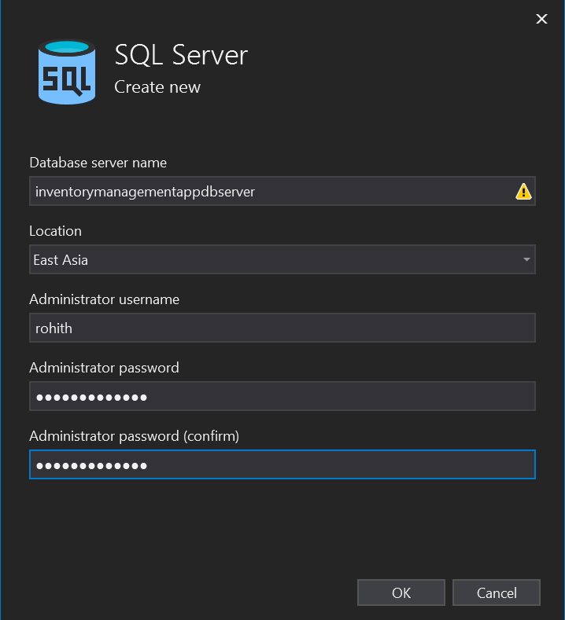

Create new SQL Server Database

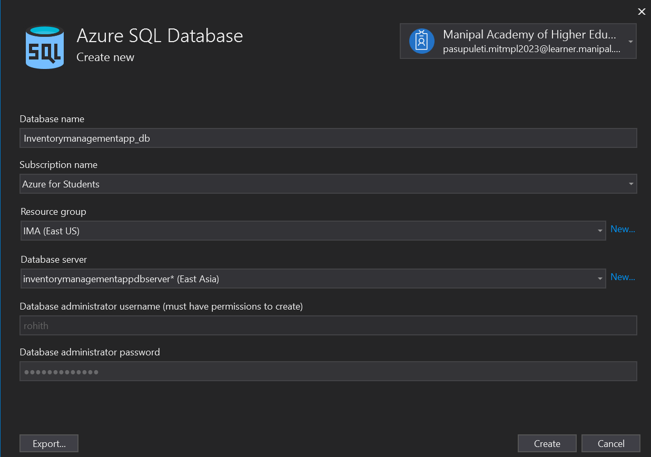

Configure SQL Server

Store Items and their Products.



 